**CNIT 182**

**Trainee Flight Ops (TFO)**

**Front End Implementation**

**MILESTONE OBJECTIVES:**

Implement the project front end as either a Tableau Workbook or Access Forms

1. Create two views (forms or sheets) using the most appropriate layout:
   1. One that displays trainee information with qualifications– one each for landing currency, flight review, and medical examination.
   2. The other to display instructor information with qualifications detailed - one each for landing currency, flight review, and medical examination.
2. Create two views (reports or sheets) using the most appropriate layout to display:
   1. A list of trainees who have not completed a medical examination in the past year
   2. A list of all courses and the lessons under each course.

**TABLEAU INSTRUCTIONS:**

1. [Download the latest version of Tableau Desktop here](https://www.tableau.com/tft/activation)
2. Click on the link above and select “Download Tableau Desktop”. On the form, enter your school email address for Business E-mail and enter “Purdue University” for Organization.
3. Activate with your product key:  TCY3-F268-AA70-8DF9-7CD9

Additional tutorial videos are available on the [Student Resource Page](https://community.tableau.com/s/students) as well as [Intro to Tableau](https://guides.lib.purdue.edu/d-velop/data-viz/tableau21)

HINT: You will need to double click the Table in the Connection Data Source window to associate tables.

HINT: Remember to use LEFT JOINS where appropriate.

HINT: It may be helpful to treat date fields as Strings unless using in a visualization.

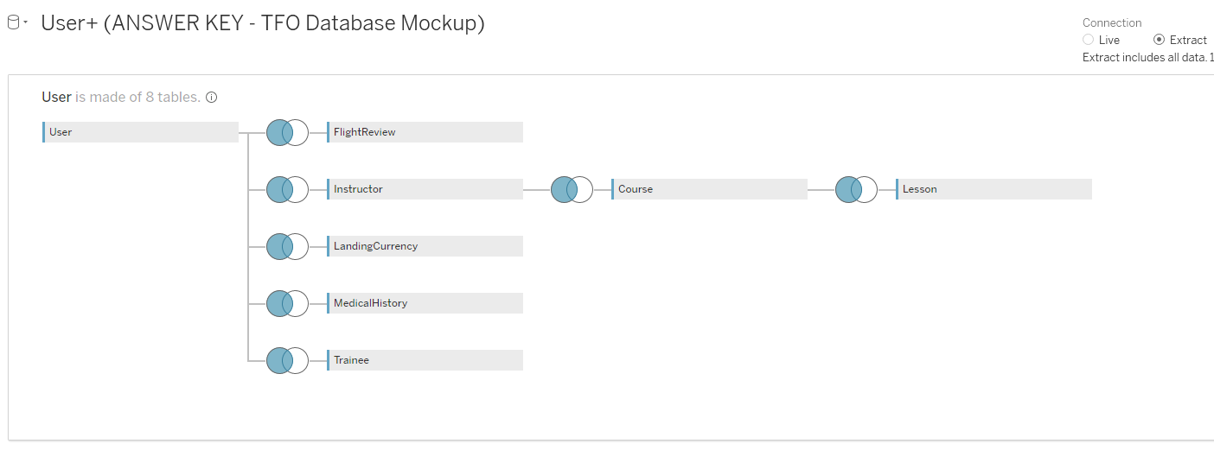

**ACCESS INSTRUCTIONS**

Access instructions are contained in the module.

HINT: First create a query that displays the personal information, if using generalizations.

HINT 2: Use sub-forms to show the qualifications on the same main form (ACCESS)